[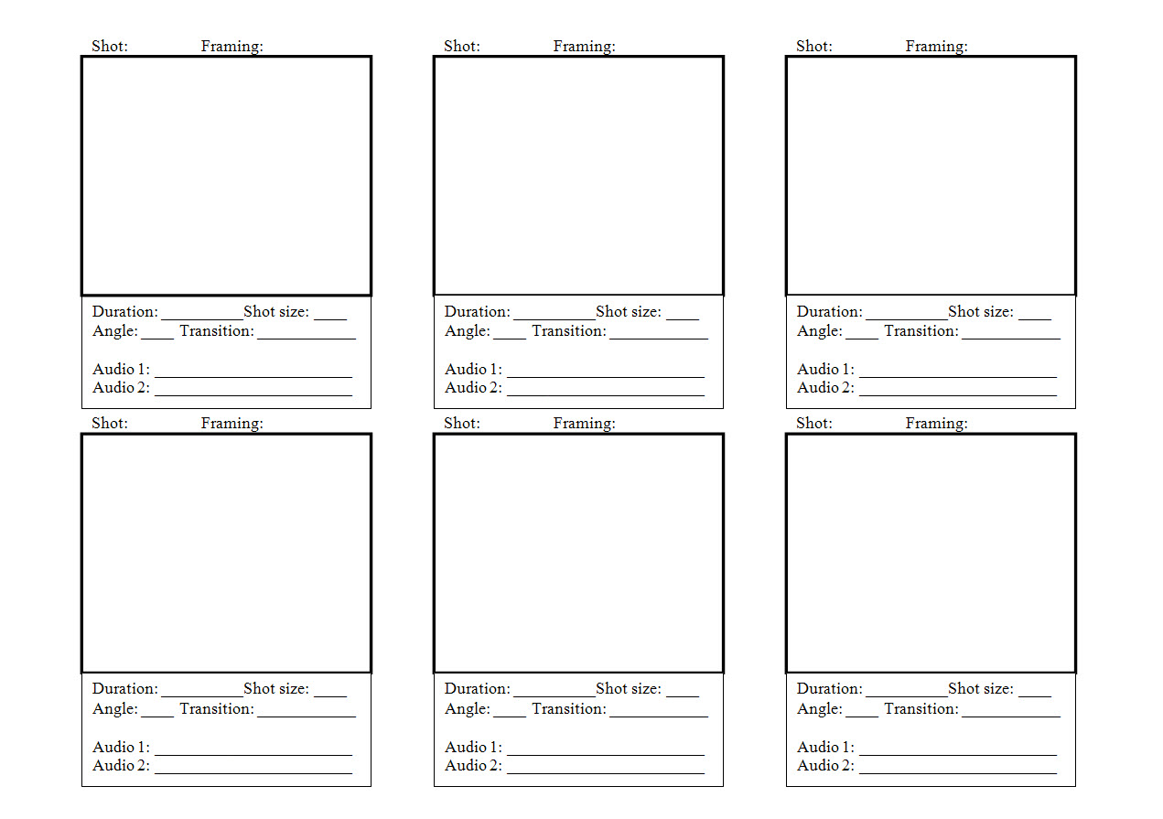](http://www.google.com.au/url?sa=i&rct=j&q=blank+storyboards+for+advertising&source=images&cd=&cad=rja&docid=RucQPoRSJeP2aM&tbnid=avZQcZGSqJ0CiM:&ved=0CAUQjRw&url=http://www.mikesovay.com/msc/1%20-%20Joe%20Burns%20Material/storyboard%20template_1.html&ei=bplHUeOfJcqxkgXfg4HACQ&bvm=bv.43828540,d.dGI&psig=AFQjCNEywpEfKQxs4VT70WOjUCRNNrYquw&ust=1363732770373981)